Resources audit of the models
Every model placed on the map (Chat City, its islets, the fog island, the vehicles; the continent is not counted), sorted by Memory: what the model takes once loaded, its mesh data (vertices and triangles) plus the textures of its materials, in MB. A model is loaded once however many buildings use it, so the biggest ones are where loading time and memory go. Buildings = how many times it is placed; Zone = how many in each zone.

Summary
290 models placed, 535.8 MB in all. The 10 biggest take 115.9 MB (22%).

Models by memory
Picture | Model | Zone | Buildings | Memory (MB)
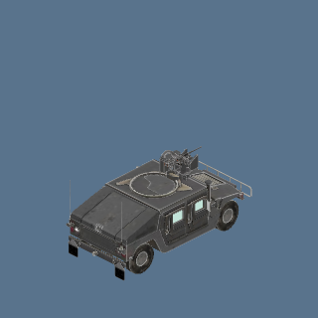 | Armoured vehicle (Humvee, grey) (humvee_grey) | FOG: ARMY BASE:2, FOG: CHECKPOINT:1, FOG: VEHICLE PARK:4 | 7 | 13.49
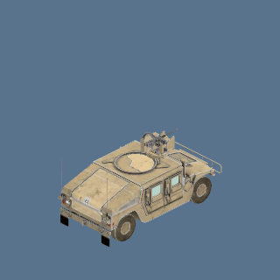 | Armoured vehicle (Humvee, sand) (humvee_sand) | NATURE:1 | 1 | 13.49
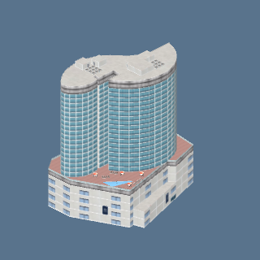 | hotels.glb: hotel_tower | CIVIC:1 | 1 | 12.51
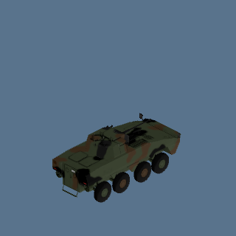 | Rosomak APC (Old version, camo green) (rosomak_apc) | PRISON:1 | 1 | 11.68
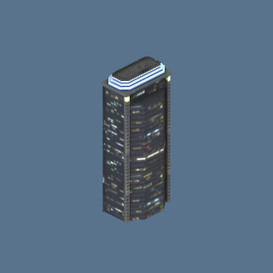 | skyline_towers.glb: sky_06 | URBAN:18 | 18 | 11.04
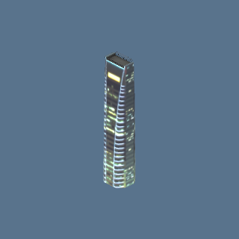 | skyline_towers.glb: sky_04 | URBAN:23 | 23 | 10.92
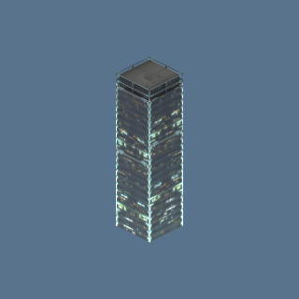 | skyline_towers.glb: sky_01 | URBAN:12 | 12 | 10.71
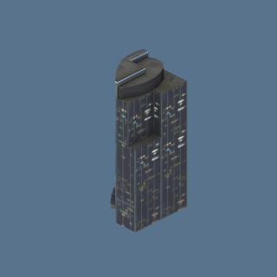 | skyline_towers.glb: sky_05 | URBAN:7 | 7 | 10.69
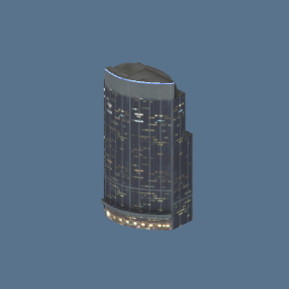 | skyline_towers.glb: sky_12 | URBAN:13 | 13 | 10.69
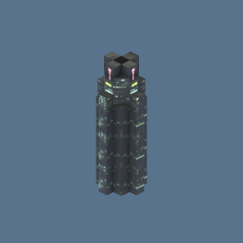 | skyline_towers.glb: sky_07 | URBAN:24 | 24 | 10.65
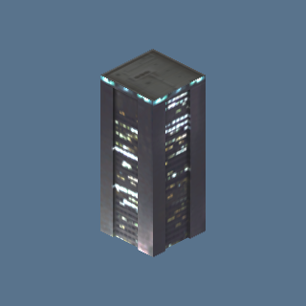 | skyline_towers.glb: sky_13 | URBAN:13 | 13 | 10.65
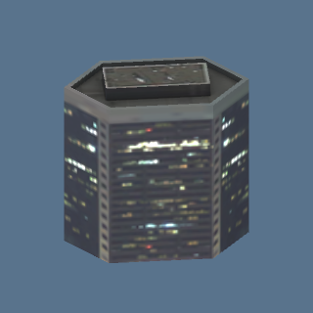 | skyline_towers.glb: sky_08 | URBAN:23 | 23 | 10.65
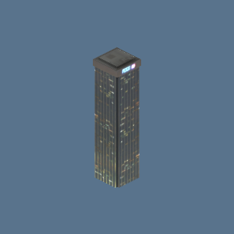 | skyline_towers.glb: sky_09 | URBAN:10 | 10 | 10.65
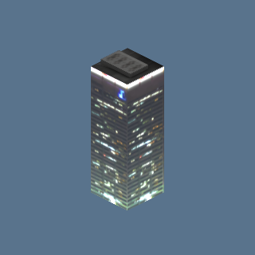 | skyline_towers.glb: sky_10 | URBAN:20 | 20 | 10.65
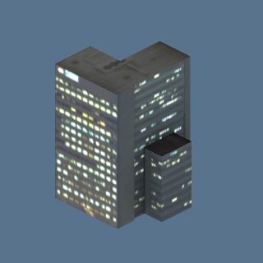 | skyline_towers.glb: sky_11 | URBAN:11 | 11 | 10.64
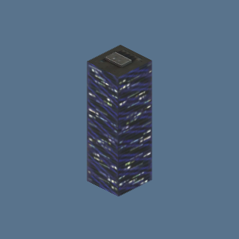 | skyline_towers.glb: sky_02 | URBAN:16 | 16 | 10.64
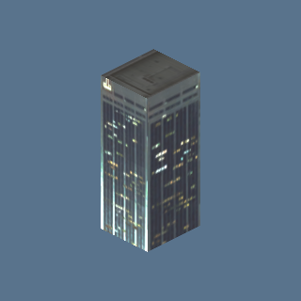 | skyline_towers.glb: sky_03 | URBAN:17 | 17 | 10.64
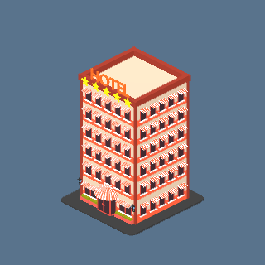 | hotel_stars_night.glb: hotel_stars | CIVIC:1 | 1 | 8.42
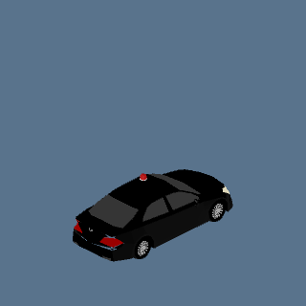 | Police car (JP) (Black, unmarked) (police_jp_black) | DESERT:3 | 3 | 7.25
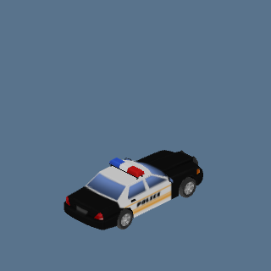 | Police car (roadblock): veh:police_us_cruiser | DESERT (roadblock):1, NATURE (roadblock):3 | 4 | 7.24
 | Police car (US) (Black and white) (police_us_cruiser) | CIVIC:2 | 2 | 7.24
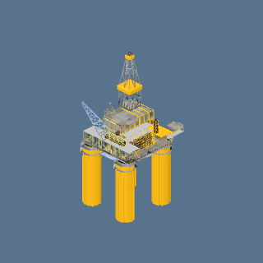 | oil_rig.glb: oil_rig | SEA:1 | 1 | 6.29
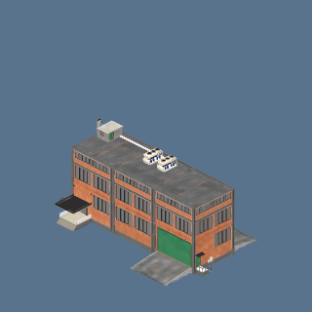 | port_tanks.glb: factory_brick | INDUSTRIAL:1 | 1 | 3.58
 | base_hall.glb: base_hall | FOG: ARMY BASE:3, FOG: NUCLEAR PLANT:1 | 4 | 3.50
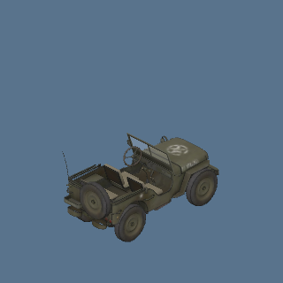 | Jeep (Willys, olive) (jeep_willys) | FOG: ARMY BASE:6, FOG: NUCLEAR PLANT:1, FOG: VEHICLE PARK:3 | 10 | 3.28
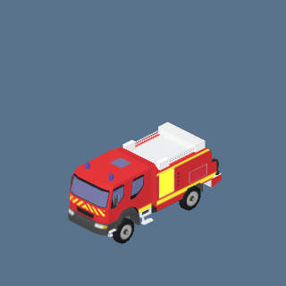 | truck_ccf_night.glb: truck_ccf | NATURE:1 | 1 | 3.15
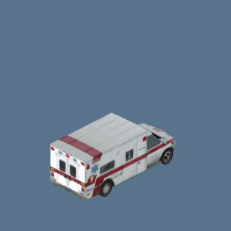 | Ambulance (Box ambulance) (p54_11_ambulance) | COMMERCIAL:1, NATURE:3, SUBURBAN:1 | 5 | 3.12
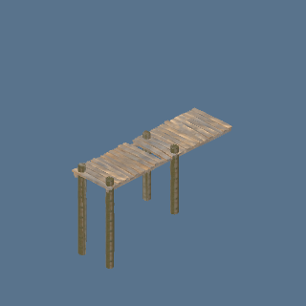 | pier_old.glb: pier_old | NATURE:2, SEA:2 | 4 | 3.10
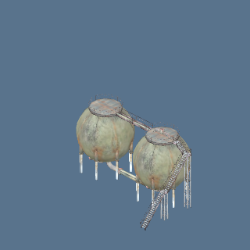 | port_tanks.glb: tank_spheres | INDUSTRIAL:1 | 1 | 3.01
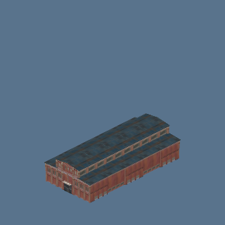 | port_halls.glb: hall_factory_1 | INDUSTRIAL:1 | 1 | 2.99
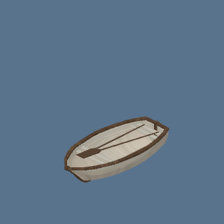 | boat_wooden.glb: boat_wooden | SEA:1 | 1 | 2.97
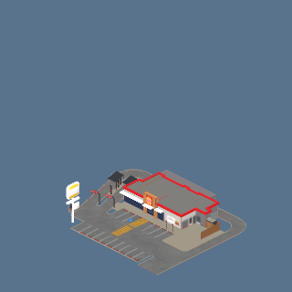 | hungry.glb: burger_king | CIVIC:1 | 1 | 2.94
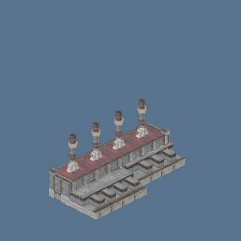 | port_halls.glb: hall_powerplant | INDUSTRIAL:1 | 1 | 2.91
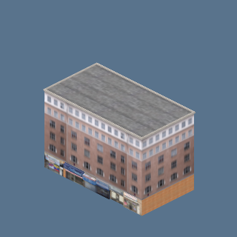 | ny_street.glb: ny_street_04_b | COMMERCIAL:7, POOR:2 | 9 | 2.86
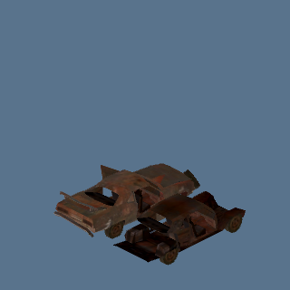 | Chassis wreck (Rusted frame) (p54_12_wreck_chassis) | DESERT:1 | 1 | 2.85
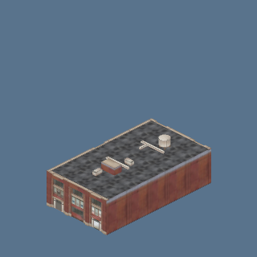 | port_halls.glb: hall_building_1 | INDUSTRIAL:1 | 1 | 2.85
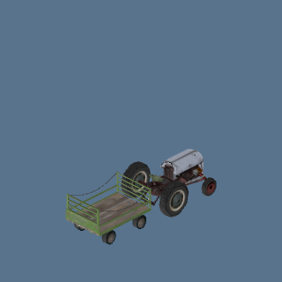 | Tractor (Vintage with trailer) (p54_43_tractor_vintage_trailer) | FARM:2 | 2 | 2.80
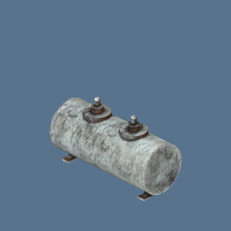 | port_tanks.glb: tank_oil | INDUSTRIAL:1 | 1 | 2.78
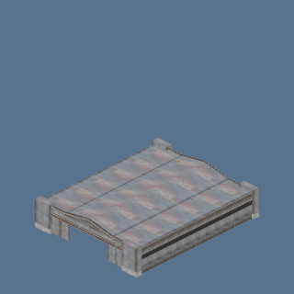 | port_halls.glb: hall_hangar | INDUSTRIAL:1 | 1 | 2.77
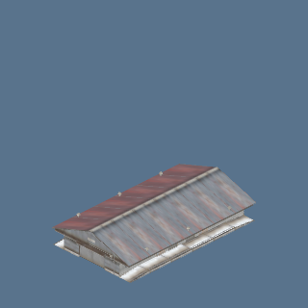 | port_halls.glb: hall_warehouse_5 | INDUSTRIAL:1 | 1 | 2.77
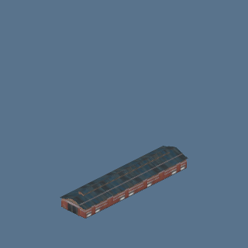 | port_halls.glb: hall_factory_2 | INDUSTRIAL:1 | 1 | 2.75
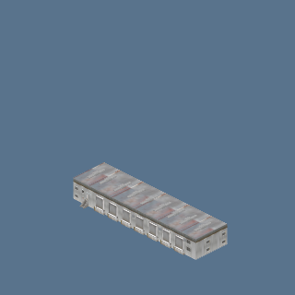 | port_halls.glb: hall_terminal | INDUSTRIAL:1 | 1 | 2.74
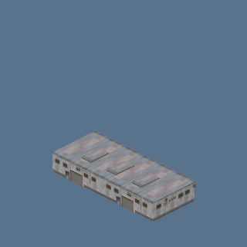 | port_sheds.glb: shed_generic_4 | INDUSTRIAL:1 | 1 | 2.73
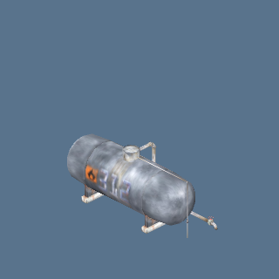 | port_tanks.glb: tank_long | INDUSTRIAL:1 | 1 | 2.72
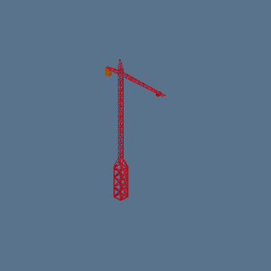 | crane.glb: crane | CIVIC:1, INDUSTRIAL:1 | 2 | 2.72
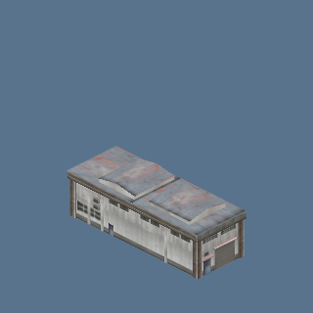 | port_halls.glb: hall_warehouse_1 | INDUSTRIAL:1 | 1 | 2.69
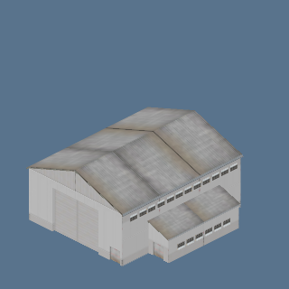 | port_sheds.glb: shed_warehouse_3 | INDUSTRIAL:1 | 1 | 2.69
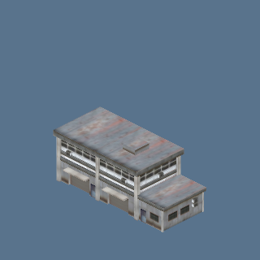 | port_sheds.glb: shed_duplex | INDUSTRIAL:1 | 1 | 2.69
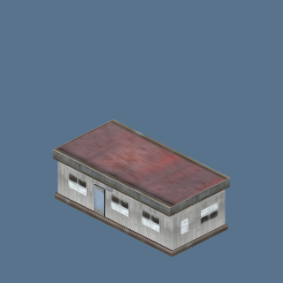 | port_sheds.glb: shed_trailer | INDUSTRIAL:1 | 1 | 2.68
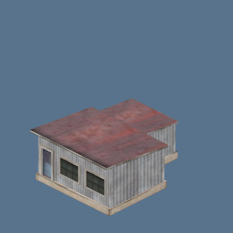 | port_sheds.glb: shed_generic_3 | INDUSTRIAL:1 | 1 | 2.67
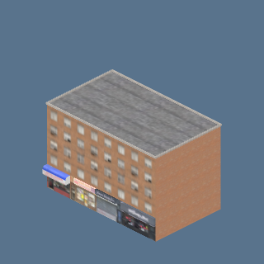 | ny_street.glb: ny_street_07_b | COMMERCIAL:3, POOR:2 | 5 | 2.52
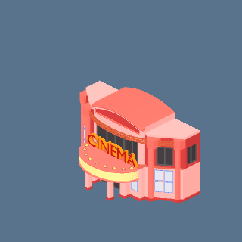 | cinema_night.glb: cinema | CIVIC:1 | 1 | 2.47
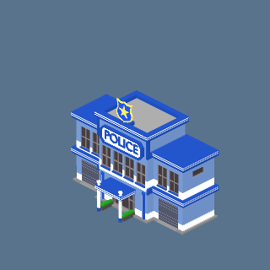 | police_hq_night.glb: police_hq | CIVIC:1 | 1 | 2.43
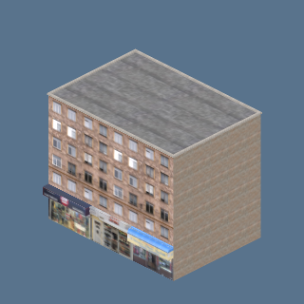 | ny_street.glb: ny_street_01_b | COMMERCIAL:1, POOR:2 | 3 | 2.35
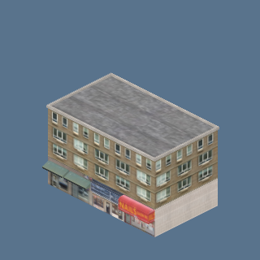 | ny_street.glb: ny_street_08_b | POOR:2 | 2 | 2.35
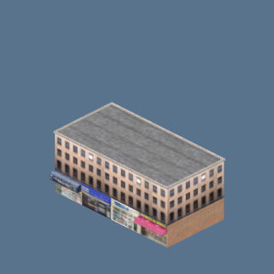 | ny_street.glb: ny_street_10_b | COMMERCIAL:16, DOWNTOWN:1, POOR:2 | 19 | 2.34
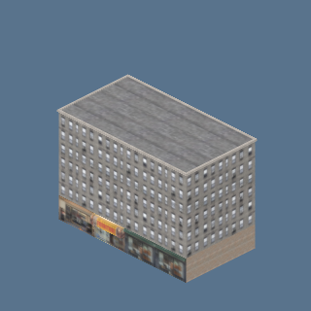 | ny_street.glb: ny_street_02_b | COMMERCIAL:3, DOWNTOWN:1, POOR:2 | 6 | 2.34
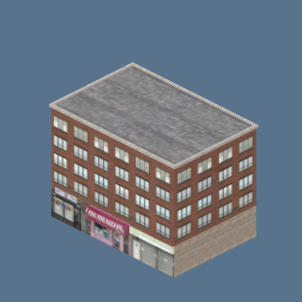 | ny_street.glb: ny_street_05_b | POOR:2 | 2 | 2.34
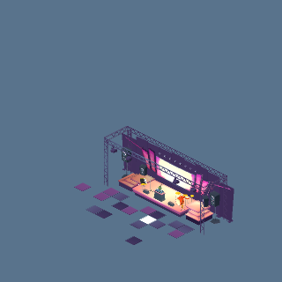 | concert.glb: concert_stage | NATURE:1 | 1 | 2.22
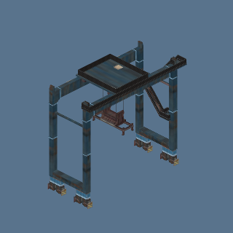 | port_towers.glb: tower_crane | INDUSTRIAL:1 | 1 | 2.21
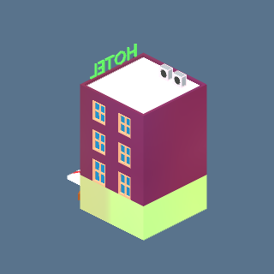 | hotel_small_night.glb: hotel_small | CIVIC:1 | 1 | 2.18
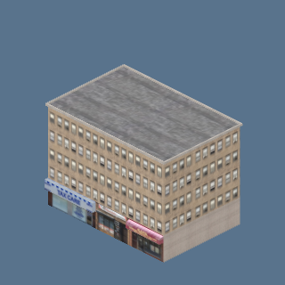 | ny_street.glb: ny_street_03_b | COMMERCIAL:2, POOR:2 | 4 | 2.18
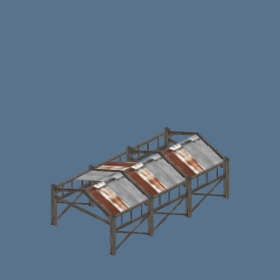 | port_sheds.glb: shed_loadbay | INDUSTRIAL:1 | 1 | 2.07
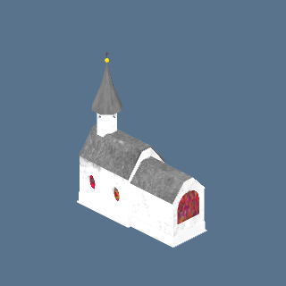 | church_low.glb: church_low | APARTMENT:1, COMMERCIAL:1, SUBURBAN:1 | 3 | 2.03
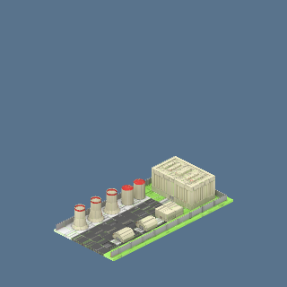 | nuclear2.glb: nuclear2 | FOG: NUCLEAR PLANT:1 | 1 | 2.02
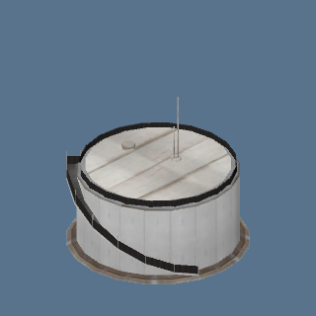 | port_towers.glb: tower_tank_1 | INDUSTRIAL:1 | 1 | 2.02
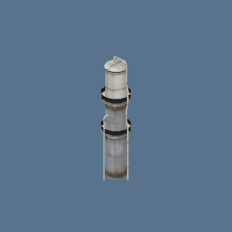 | port_towers.glb: tower_tank_4 | INDUSTRIAL:1 | 1 | 2.02
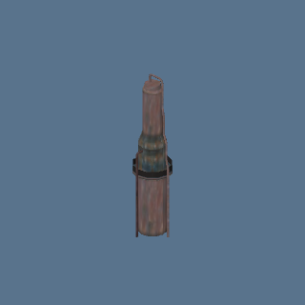 | port_towers.glb: tower_tank_5 | INDUSTRIAL:1 | 1 | 2.02
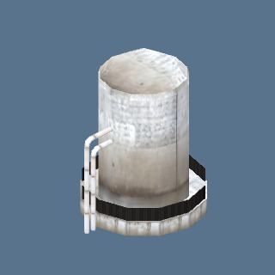 | port_towers.glb: tower_tank_3 | INDUSTRIAL:1 | 1 | 2.01
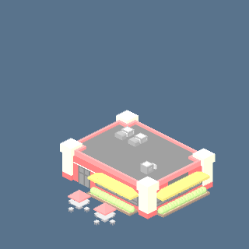 | free_mini.glb: m10 | APARTMENT:2, COMMERCIAL:1 | 3 | 1.96
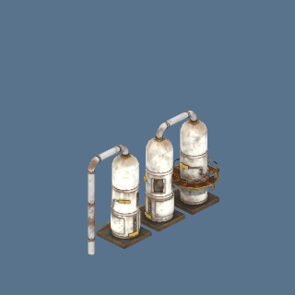 | port_tanks.glb: tank_old | INDUSTRIAL:1 | 1 | 1.94
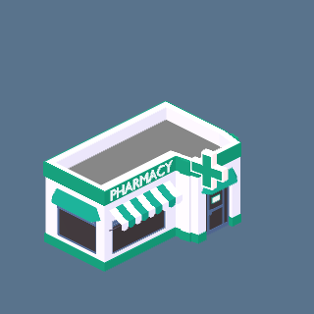 | pharmacy_night.glb: pharmacy | CIVIC:2 | 2 | 1.90
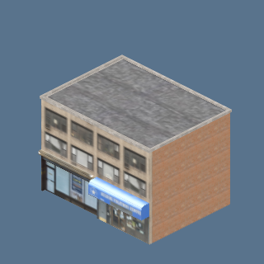 | ny_street.glb: ny_street_06_b | COMMERCIAL:4, POOR:2 | 6 | 1.85
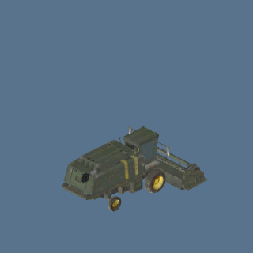 | Harvester (Olive green) (p54_21_harvester_olive) | FARM:2 | 2 | 1.84
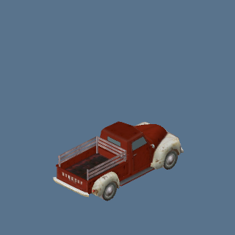 | Pickup (1940s style, red) (p54_26_pickup_40s_red) | FARM:1 | 1 | 1.80
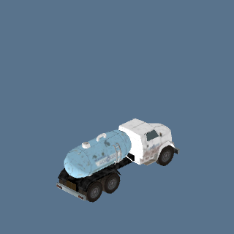 | Tanker (Water tanker) (p54_10_tanker_water) | INDUSTRIAL:1, NATURE:1 | 2 | 1.80
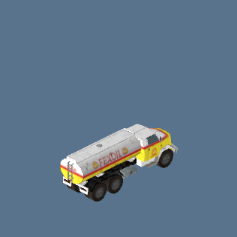 | Tanker (Fuel tanker) (p54_18_tanker_fuel) | INDUSTRIAL:1 | 1 | 1.79
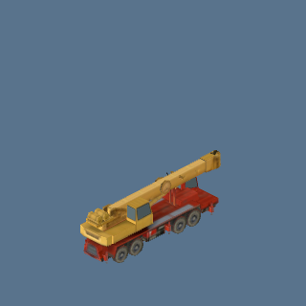 | Mobile crane (Truck-mounted, red/yellow) (p54_35_crane_truck_mobile) | INDUSTRIAL:1 | 1 | 1.78
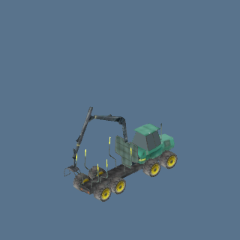 | Forwarder (Timber, green) (p54_42_forwarder_green) | FARM:1 | 1 | 1.76
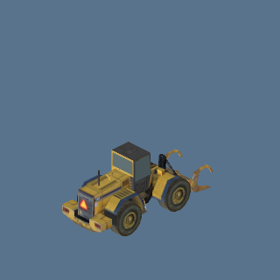 | Wheel loader (Claw bucket, yellow) (p54_41_loader_claw_yellow) | FARM:1 | 1 | 1.75
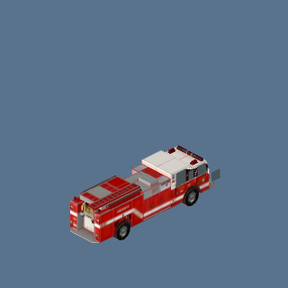 | Fire truck (Red pumper) (p54_33_fire_truck) | FOG: ARMY BASE:1, NATURE:2 | 3 | 1.74
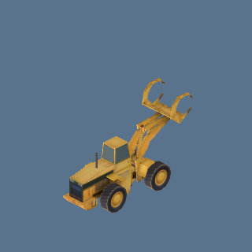 | Wheel loader (Grapple, yellow) (p54_38_loader_grapple_yellow) | INDUSTRIAL:1 | 1 | 1.74
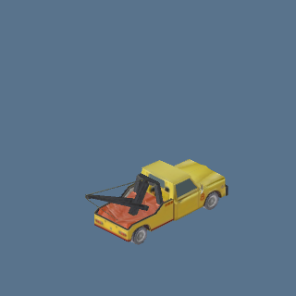 | Tow truck (Yellow) (p54_08_tow_truck_yellow) | FOG: ARMY BASE:1 | 1 | 1.73
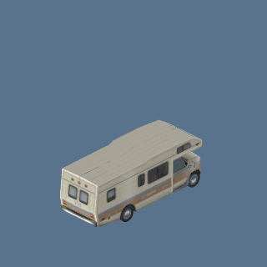 | Motorhome (Class A, beige) (p54_31_rv_class_a_beige) | DESERT:1 | 1 | 1.72
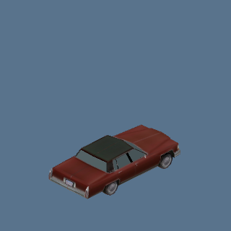 | Sedan (Classic 70s, maroon) (p54_03_sedan_classic_maroon) | CIVIC:3 | 3 | 1.72
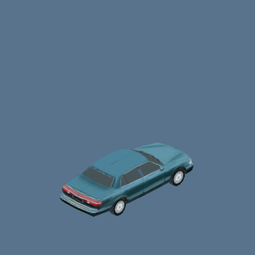 | Sedan (90s, teal) (p54_05_sedan_90s_teal) | CIVIC:3 | 3 | 1.71
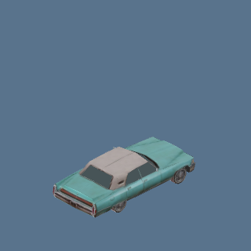 | Sedan (Classic hardtop, teal) (p54_24_sedan_hardtop_teal) | CIVIC:2 | 2 | 1.71
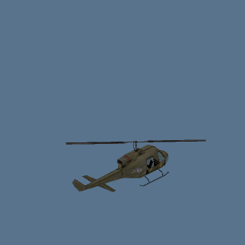 | Helicopter (Military, olive) (p54_46_helicopter_military) | DESERT:1, FOG: ARMY BASE:1, SEA:1 | 3 | 1.71
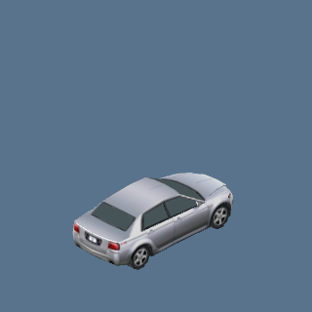 | Sedan (Modern, silver) (p54_04_sedan_modern_silver) | CIVIC:4 | 4 | 1.71
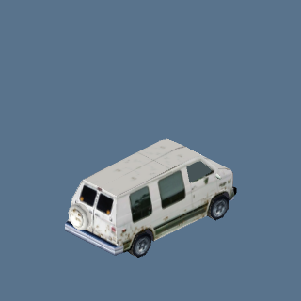 | Van (Conversion van, white) (p54_02_van_conversion_white) | CIVIC:10, COMMERCIAL:1 | 11 | 1.70
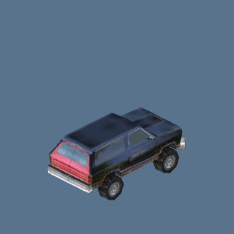 | SUV (Off-road 4x4, navy) (p54_01_suv_offroad_navy) | NATURE:1 | 1 | 1.70
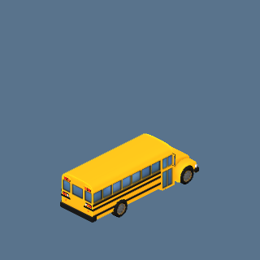 | School bus (Yellow) (school_bus) | NATURE:1 | 1 | 1.69
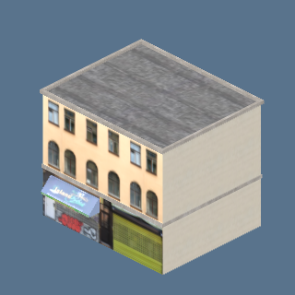 | ny_street.glb: ny_street_09_b | COMMERCIAL:1, POOR:2 | 3 | 1.67
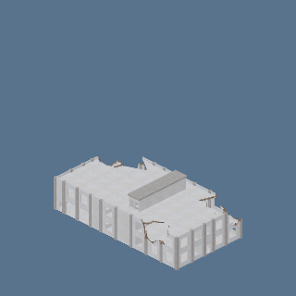 | industrial.glb: ruin | INDUSTRIAL:1 | 1 | 1.62
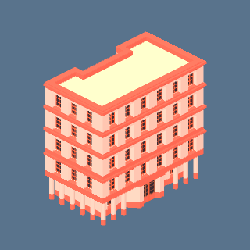 | accommodations.glb: flat10 | QUARTER:2 | 2 | 1.61
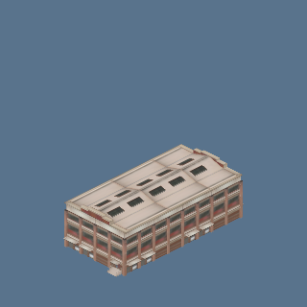 | port_halls.glb: hall_building_10 | INDUSTRIAL:1 | 1 | 1.57
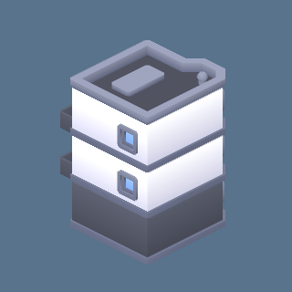 | building-b.glb | APARTMENT:4, COMMERCIAL:27, ENTERTAINMENT:4, SUBURBAN:3 | 38 | 1.54
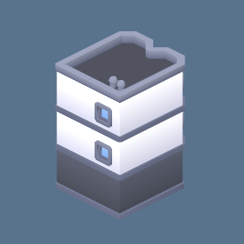 | building-a.glb | APARTMENT:2, COMMERCIAL:31, INDUSTRIAL:2, POOR:2, SUBURBAN:1 | 38 | 1.51
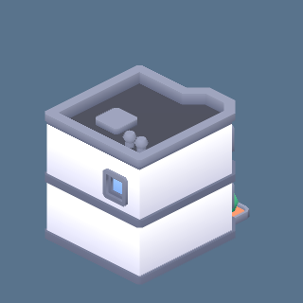 | building-c.glb | APARTMENT:5, COMMERCIAL:12, POOR:1, SUBURBAN:2 | 20 | 1.51
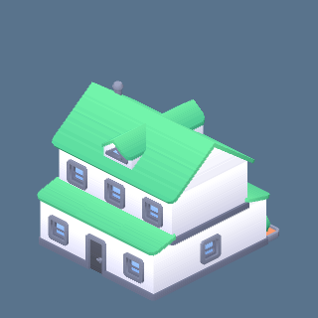 | building-type-t.glb | APARTMENT:3, SUBURBAN:4 | 7 | 1.50
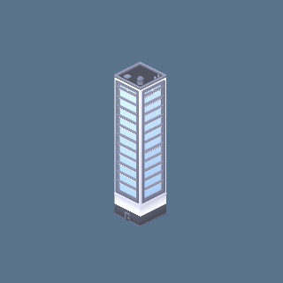 | building-skyscraper-d.glb | DOWNTOWN:9 | 9 | 1.50
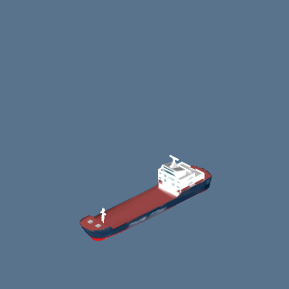 | boat_cargo.glb: boat_cargo | SEA:6 | 6 | 1.50
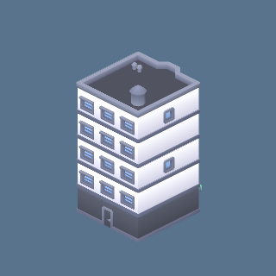 | building-l.glb | APARTMENT:2, INDUSTRIAL:1 | 3 | 1.49
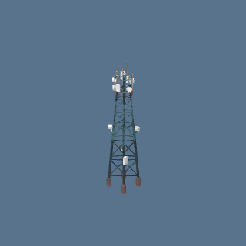 | port_towers.glb: tower_radio | INDUSTRIAL:1 | 1 | 1.49
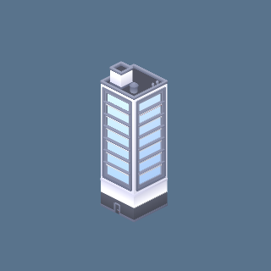 | building-skyscraper-c.glb | DOWNTOWN:9 | 9 | 1.48
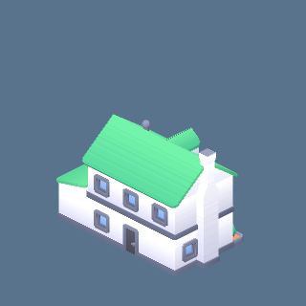 | building-type-d.glb | APARTMENT:2, SUBURBAN:1 | 3 | 1.48
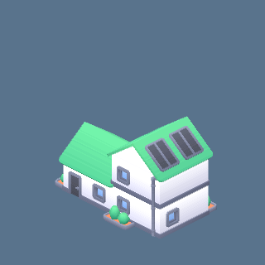 | building-type-b.glb | APARTMENT:2, SUBURBAN:1 | 3 | 1.48
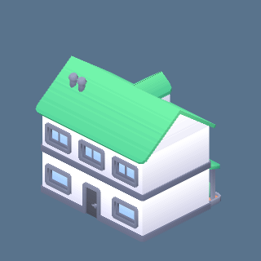 | building-type-e.glb | APARTMENT:1, SUBURBAN:3 | 4 | 1.48
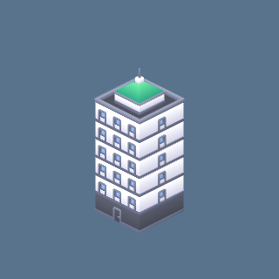 | building-m.glb | COMMERCIAL:1 | 1 | 1.47
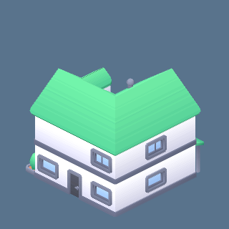 | building-type-f.glb | APARTMENT:1, SUBURBAN:1 | 2 | 1.47
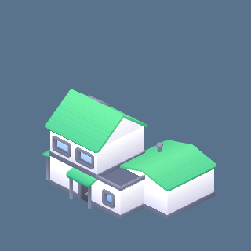 | building-type-n.glb | APARTMENT:2, SUBURBAN:12 | 14 | 1.47
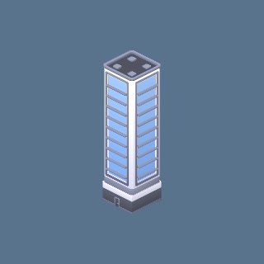 | building-skyscraper-b.glb | DOWNTOWN:10, ENTERTAINMENT:1 | 11 | 1.47
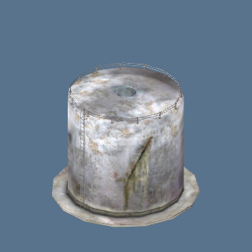 | port_tanks.glb: tank_big | INDUSTRIAL:1 | 1 | 1.47
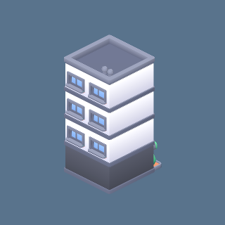 | building-f.glb | ENTERTAINMENT:6 | 6 | 1.47
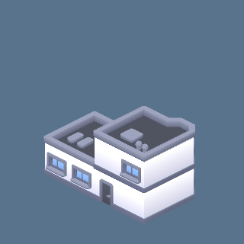 | building-e.glb | APARTMENT:1, CIVIC:4, COMMERCIAL:18, SUBURBAN:2 | 25 | 1.46
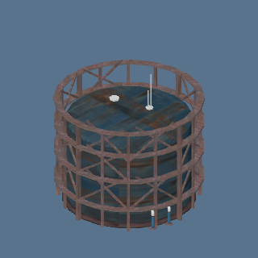 | port_towers.glb: tower_tank_2 | INDUSTRIAL:1 | 1 | 1.46
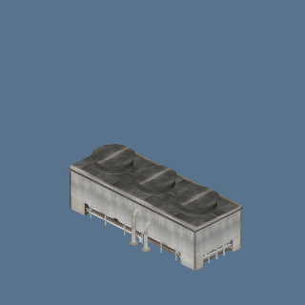 | port_sheds.glb: shed_works_2 | INDUSTRIAL:1 | 1 | 1.45
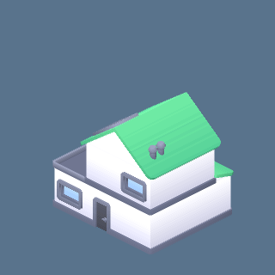 | building-type-u.glb | APARTMENT:1, SUBURBAN:2 | 3 | 1.45
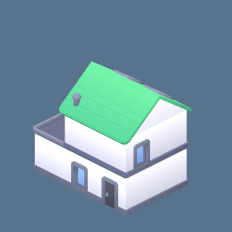 | building-type-o.glb | APARTMENT:1, SUBURBAN:2 | 3 | 1.45
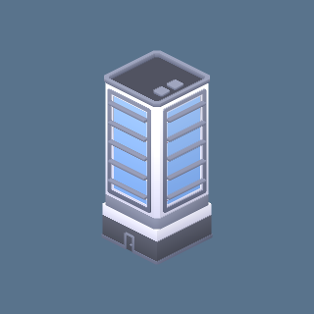 | building-skyscraper-a.glb | DOWNTOWN:9 | 9 | 1.44
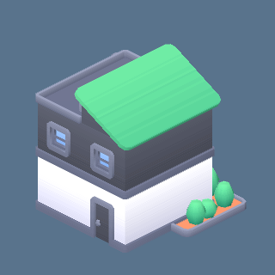 | building-type-l.glb | APARTMENT:2, SUBURBAN:2 | 4 | 1.44
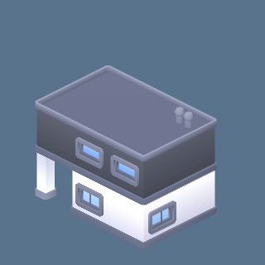 | building-type-p.glb | SUBURBAN:3 | 3 | 1.44
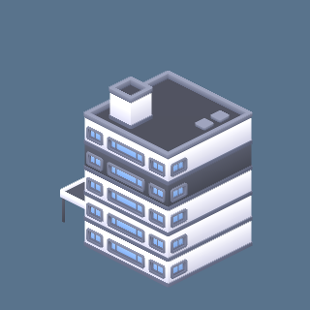 | building-n.glb | COMMERCIAL:4, ENTERTAINMENT:21 | 25 | 1.44
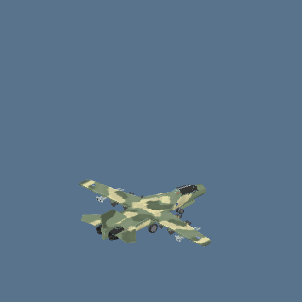 | jet_f111.glb: jet_f111 | FOG: SKY NORTH OF THE MAIN ISLAND:3 | 3 | 1.44
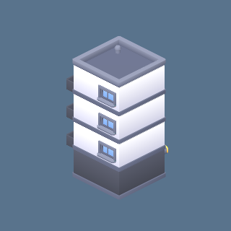 | building-g.glb | APARTMENT:5, DOWNTOWN:5 | 10 | 1.44
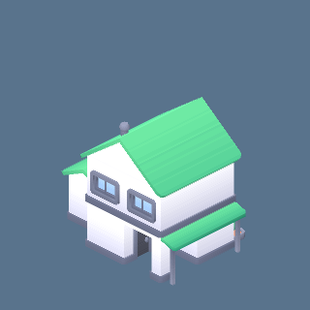 | building-type-s.glb | APARTMENT:1, SUBURBAN:5 | 6 | 1.43
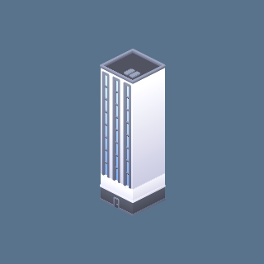 | building-skyscraper-e.glb | DOWNTOWN:13 | 13 | 1.43
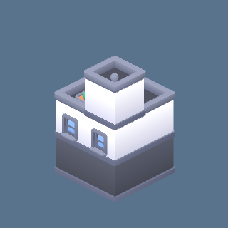 | building-d.glb | APARTMENT:4, COMMERCIAL:17, ENTERTAINMENT:3, POOR:2, SUBURBAN:4 | 30 | 1.43
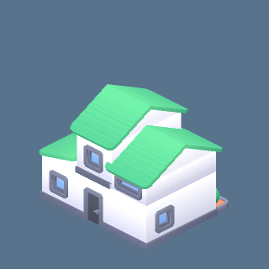 | building-type-c.glb | APARTMENT:1, SUBURBAN:4 | 5 | 1.43
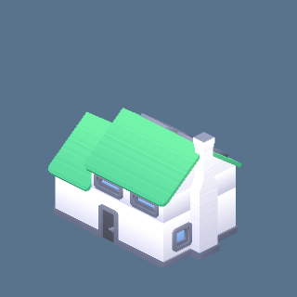 | building-type-j.glb | SUBURBAN:10 | 10 | 1.43
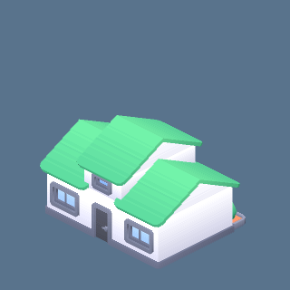 | building-type-a.glb | APARTMENT:2, SUBURBAN:2 | 4 | 1.43
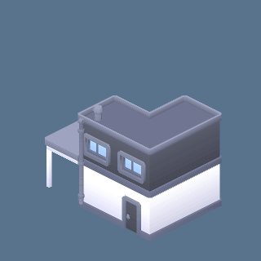 | building-type-q.glb | SUBURBAN:5 | 5 | 1.43
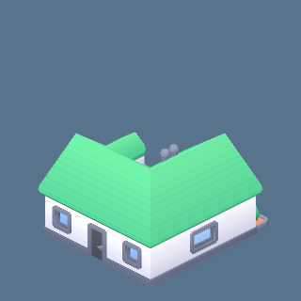 | building-type-m.glb | SUBURBAN:1 | 1 | 1.43
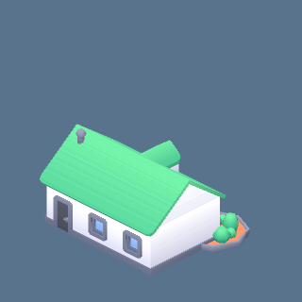 | building-type-g.glb | APARTMENT:1, SUBURBAN:1 | 2 | 1.42
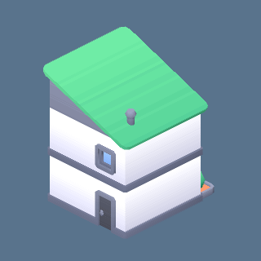 | building-type-k.glb | APARTMENT:2, SUBURBAN:4 | 6 | 1.42
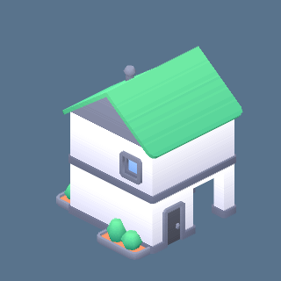 | building-type-r.glb | APARTMENT:1, SUBURBAN:3 | 4 | 1.42
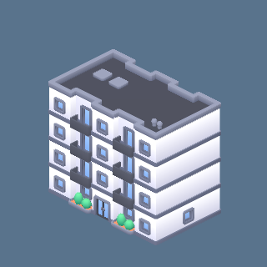 | building-j.glb | APARTMENT:4 | 4 | 1.41
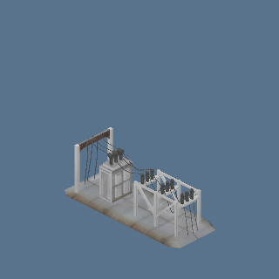 | port_sheds.glb: shed_station | INDUSTRIAL:1 | 1 | 1.41
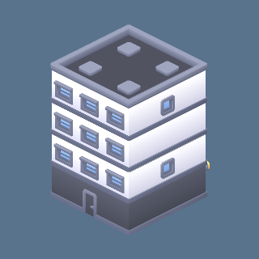 | building-i.glb | APARTMENT:5, COMMERCIAL:2 | 7 | 1.40
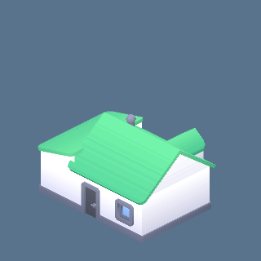 | building-type-i.glb | APARTMENT:2, SUBURBAN:3 | 5 | 1.40
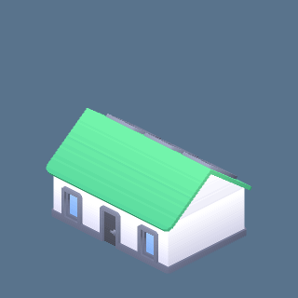 | building-type-h.glb | APARTMENT:1, SUBURBAN:3 | 4 | 1.40
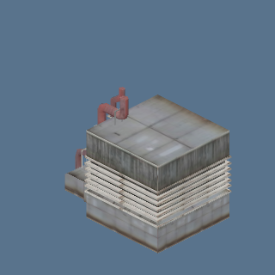 | port_sheds.glb: shed_works_1 | INDUSTRIAL:1 | 1 | 1.40
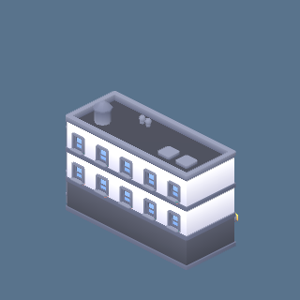 | building-k.glb | APARTMENT:11, COMMERCIAL:11, ENTERTAINMENT:1, POOR:1, SUBURBAN:3 | 27 | 1.39
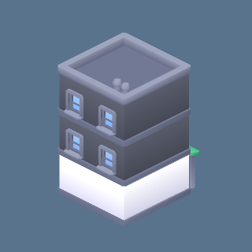 | building-h.glb | APARTMENT:1, COMMERCIAL:9, ENTERTAINMENT:5, POOR:1, SUBURBAN:2 | 18 | 1.39
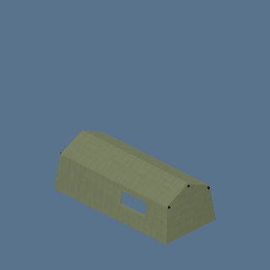 | camp_tent_jungle.glb: camp_tent_jungle | FOG: ARMY BASE:18 | 18 | 1.39
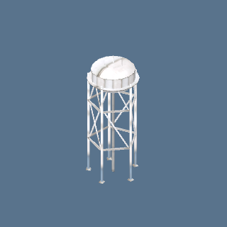 | port_towers.glb: tower_water | INDUSTRIAL:1 | 1 | 1.37
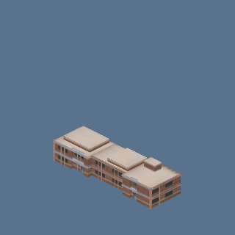 | port_halls.glb: hall_warehouse_4 | INDUSTRIAL:1 | 1 | 1.36
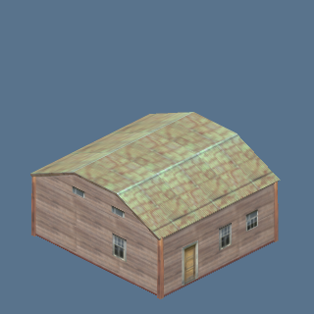 | outpost.glb: ranch_b | CIVIC:1 | 1 | 1.36
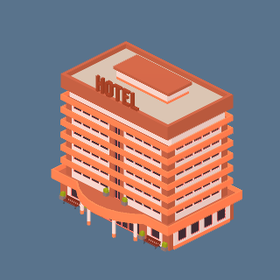 | hotel_low.glb: hotel_orange | CIVIC:1 | 1 | 1.35
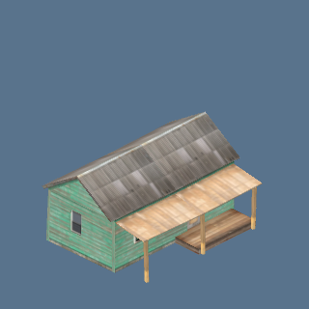 | outpost.glb: ranch_a | CIVIC:1 | 1 | 1.35
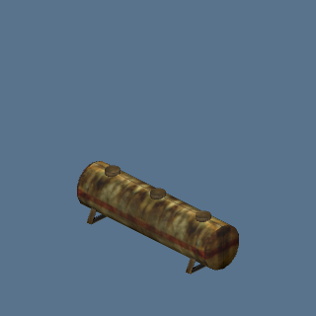 | port_tanks.glb: tank_rusty | INDUSTRIAL:1 | 1 | 1.35
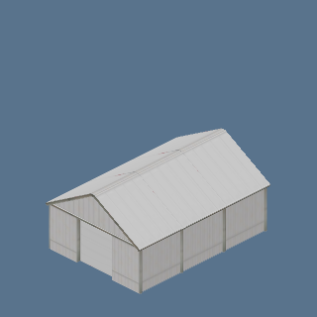 | port_sheds.glb: shed_small_4 | INDUSTRIAL:1 | 1 | 1.35
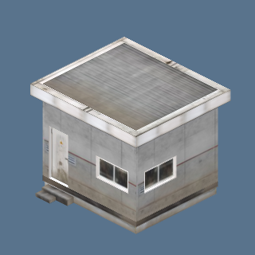 | port_towers.glb: tower_hut | INDUSTRIAL:1 | 1 | 1.34
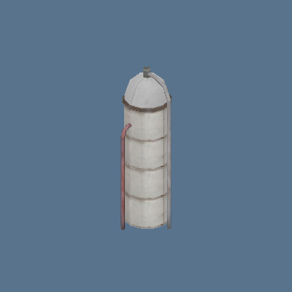 | port_towers.glb: tower_silo | INDUSTRIAL:1 | 1 | 1.34
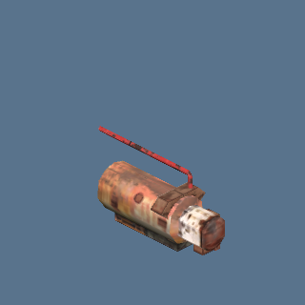 | outpost.glb: generator | CIVIC:1 | 1 | 1.34
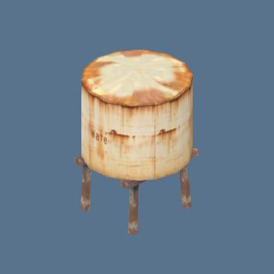 | outpost.glb: water_tank | CIVIC:1 | 1 | 1.34
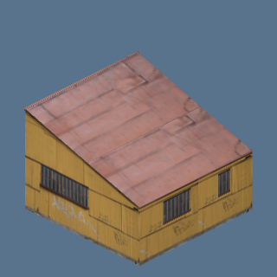 | outpost.glb: barrack_b | CIVIC:1, DESERT:1 | 2 | 1.34
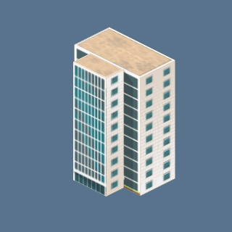 | un_tower.glb: un_tower | CIVIC:1 | 1 | 1.33
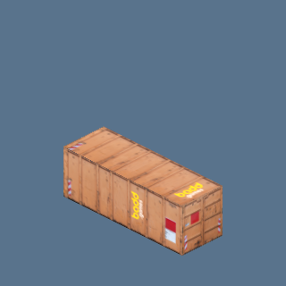 | outpost.glb: container | CIVIC:1 | 1 | 1.33
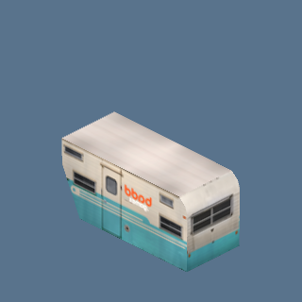 | outpost.glb: trailer_a | CIVIC:1 | 1 | 1.33
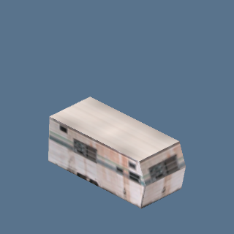 | outpost.glb: trailer_b | CIVIC:1, DESERT:1 | 2 | 1.33
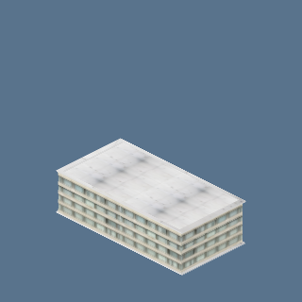 | poor.glb: slab | POOR:13 | 13 | 1.22
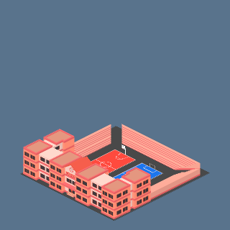 | public_main.glb: school | CIVIC:1 | 1 | 1.17
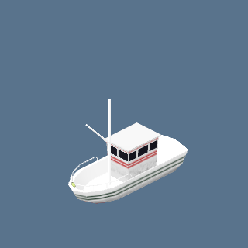 | boat_simple.glb: boat_simple | SEA:9 | 9 | 1.06
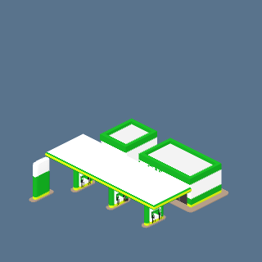 | public_main.glb: gas_station | CIVIC:1 | 1 | 1.01
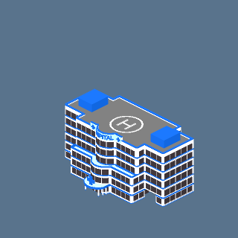 | public_main.glb: hospital | CIVIC:2 | 2 | 0.98
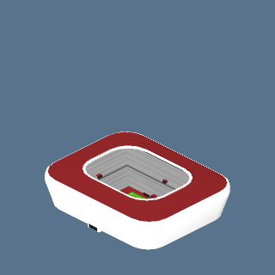 | stadium.glb: stadium | CIVIC:1 | 1 | 0.87
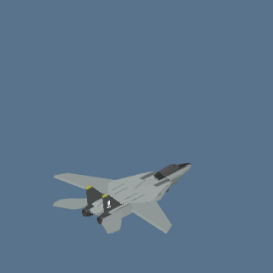 | jet_f14.glb: jet_f14 | FOG: ARMY BASE:12 | 12 | 0.79
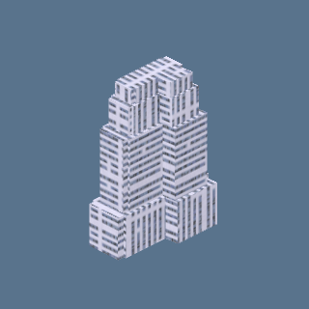 | urban.glb: tower6 | POOR:2 | 2 | 0.78
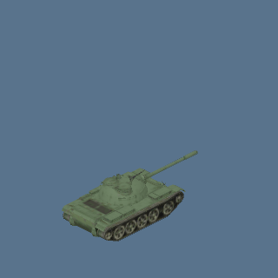 | army_tanks.glb: tank_t55 | FOG: CHECKPOINT:2, FOG: NUCLEAR PLANT:1, FOG: VEHICLE PARK:8 | 11 | 0.78
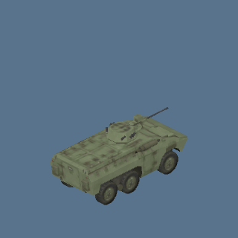 | army_apc.glb: apc_ee11_aa | FOG: ARMY BASE:1, FOG: NUCLEAR PLANT:2, FOG: VEHICLE PARK:3 | 6 | 0.77
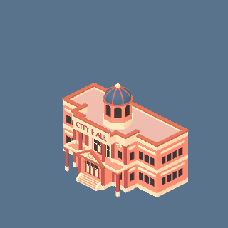 | public_main.glb: city_hall | CIVIC:1 | 1 | 0.76
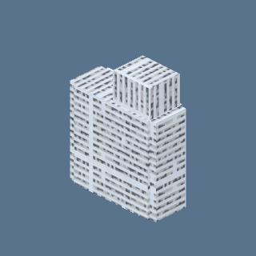 | urban.glb: tower5 | POOR:2 | 2 | 0.76
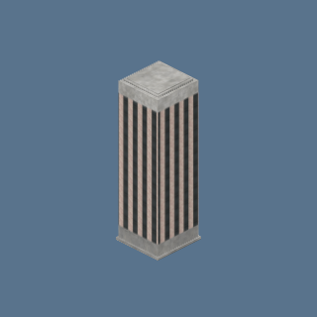 | urban.glb: tower0 | POOR:3 | 3 | 0.75
 | accommodations.glb: flat8 | APARTMENT:13, QUARTER:28 | 41 | 0.73
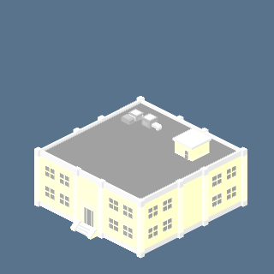 | free_mini.glb: m2 | APARTMENT:1, QUARTER:1 | 2 | 0.70
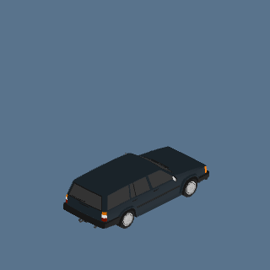 | Wagon, sloped rear (Black) (m8_wagon_sloped_black) | CIVIC:1 | 1 | 0.69
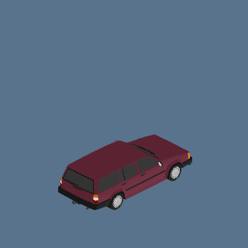 | Wagon, sloped rear (Burgundy) (m8_wagon_sloped_burgundy) | CIVIC:2 | 2 | 0.69
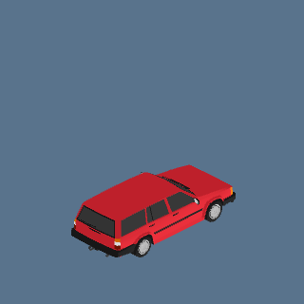 | Wagon, sloped rear (Red) (m8_wagon_sloped_red) | CIVIC:3 | 3 | 0.69
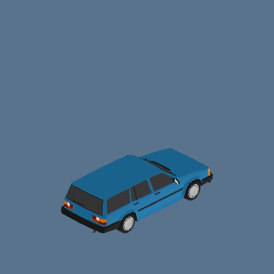 | Station wagon (Blue) (m8_wagon_blue) | CIVIC:1, COMMERCIAL:1 | 2 | 0.69
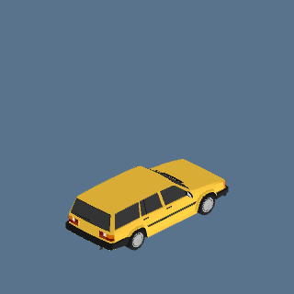 | Station wagon (Mustard) (m8_wagon_mustard) | CIVIC:1 | 1 | 0.69
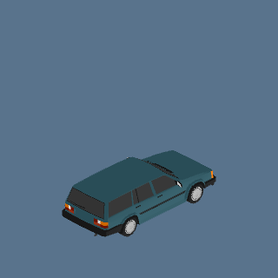 | Station wagon (Teal) (m8_wagon_teal) | CIVIC:1, COMMERCIAL:1 | 2 | 0.69
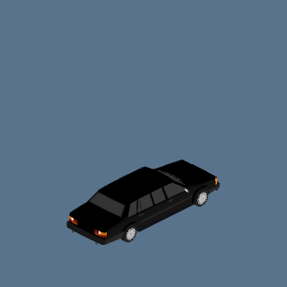 | Long sedan (Black) (m8_long_sedan_black) | NATURE:4 | 4 | 0.68
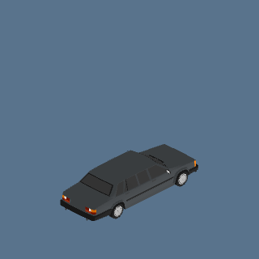 | Long sedan (Charcoal) (m8_long_sedan_charcoal) | NATURE:4 | 4 | 0.68
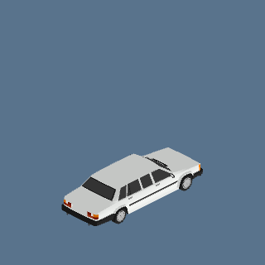 | Long sedan (Silver) (m8_long_sedan_silver) | CIVIC:1, COMMERCIAL:2, NATURE:4 | 7 | 0.68
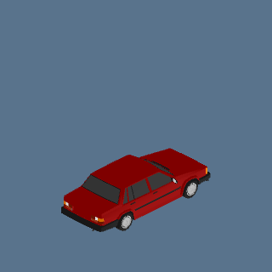 | Sedan (Dark red) (m8_sedan_dark_red) | CIVIC:3, COMMERCIAL:1 | 4 | 0.68
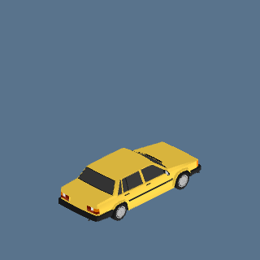 | Sedan (Mustard) (m8_sedan_mustard) | CIVIC:3, COMMERCIAL:1, NATURE:12 | 16 | 0.68
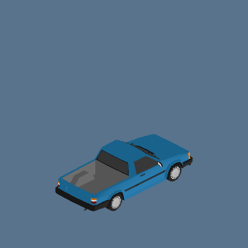 | Pickup (Blue) (m8_pickup_blue) | COMMERCIAL:1 | 1 | 0.66
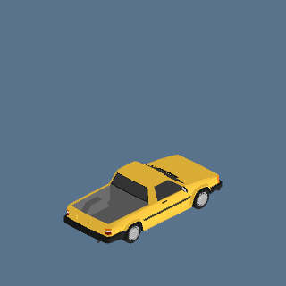 | Pickup (Mustard) (m8_pickup_mustard) | CIVIC:1 | 1 | 0.66
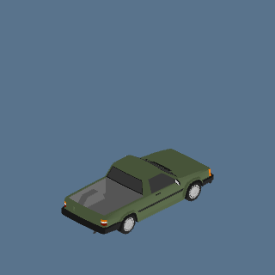 | Pickup (Olive) (m8_pickup_olive) | CIVIC:2, COMMERCIAL:4 | 6 | 0.66
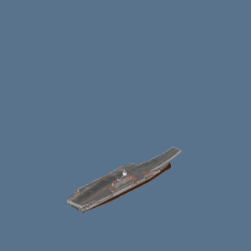 | carrier.glb: carrier | FOG: SEA AROUND THE ISLAND:6 | 6 | 0.59
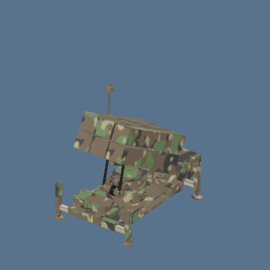 | sam_nasams.glb: sam_nasams | FOG: ARMY BASE:3 | 3 | 0.59
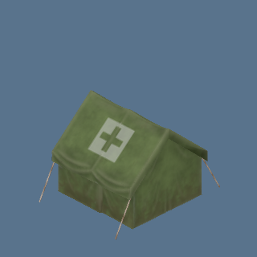 | camp_tent_medical.glb: camp_tent_medical | FOG: ARMY BASE:6 | 6 | 0.59
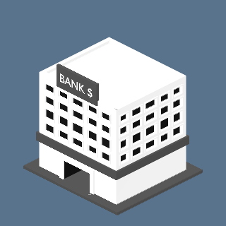 | bank_min.glb: bank_minimalist | CIVIC:1 | 1 | 0.53
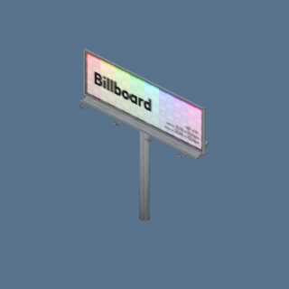 | billboard.glb: billboard | APARTMENT:4, COMMERCIAL:1, DOWNTOWN:1, ENTERTAINMENT:1, POOR:1, PRISON:1, QUARTER:5, SUBURBAN:2 | 16 | 0.53
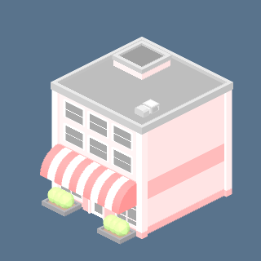 | free_mini.glb: m9 | SUBURBAN:1 | 1 | 0.51
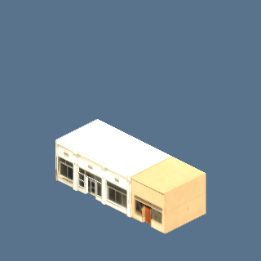 | street.glb: shop_amber | POOR:1, SUBURBAN:1 | 2 | 0.49
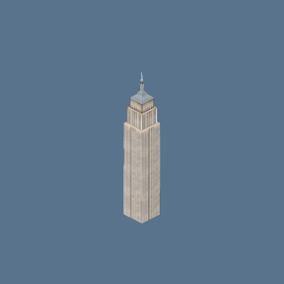 | ny_buildings.glb: empire_state | CIVIC:1 | 1 | 0.47
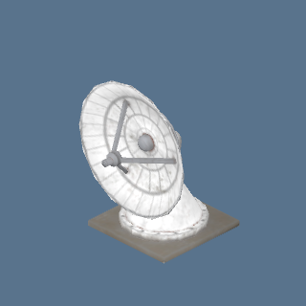 | dish.glb: dish | CIVIC:3, INDUSTRIAL:3 | 6 | 0.47
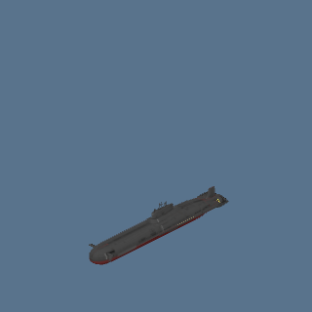 | boat_sub.glb: boat_sub | SEA:17 | 17 | 0.46
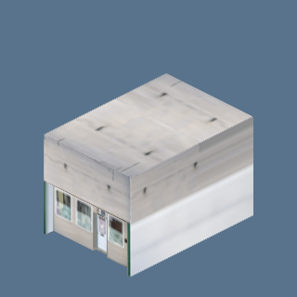 | street.glb: shop_zinc | POOR:1, SUBURBAN:1 | 2 | 0.43
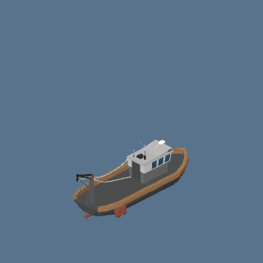 | boat_fishing.glb: boat_fishing | SEA:1 | 1 | 0.43
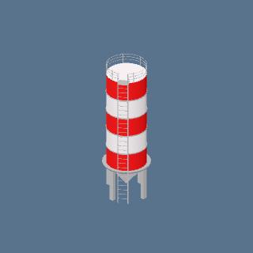 | silo.glb: silo | INDUSTRIAL:3 | 3 | 0.42
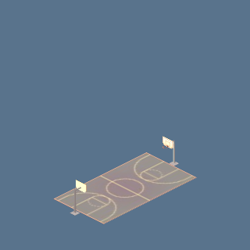 | court.glb: basketball_court | QUARTER:1, SUBURBAN:1 | 2 | 0.42
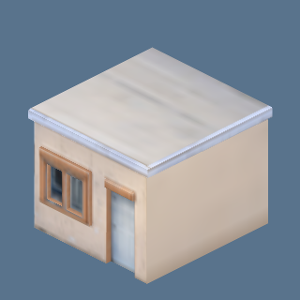 | street.glb: shop_hut | COMMERCIAL:5 | 5 | 0.41
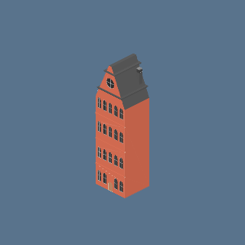 | euro.glb: townhouse_a | QUARTER:1 | 1 | 0.41
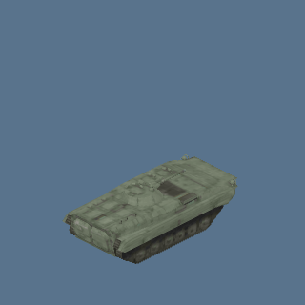 | army_apc.glb: apc_bmp1 | FOG: VEHICLE PARK:8 | 8 | 0.41
 | carto.glb: restaurant | APARTMENT:1 | 1 | 0.39
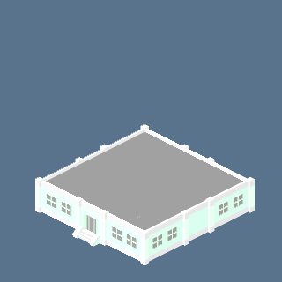 | free_mini.glb: m3 | COMMERCIAL:5 | 5 | 0.38
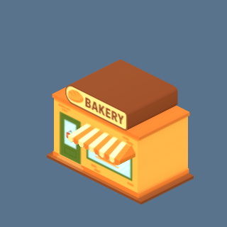 | carto.glb: bakery | SUBURBAN:2 | 2 | 0.37
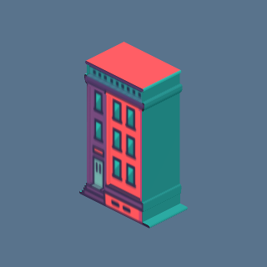 | carto.glb: town7 | QUARTER:1 | 1 | 0.36
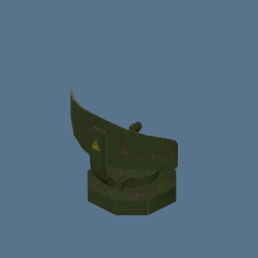 | camp_radar.glb: camp_radar | FOG: ARMY BASE:2 | 2 | 0.35
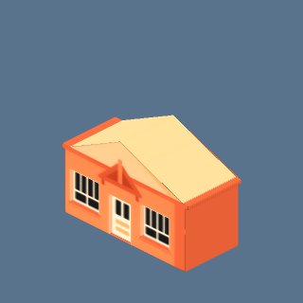 | carto.glb: house0 | APARTMENT:2, QUARTER:1, SUBURBAN:13 | 16 | 0.35
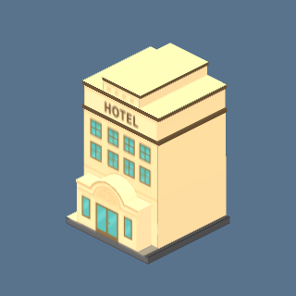 | carto.glb: hotel1 | COMMERCIAL:2 | 2 | 0.35
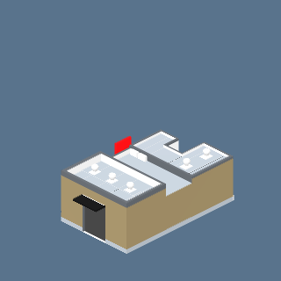 | mcdonalds.glb: mcdonalds | CIVIC:5 | 5 | 0.35
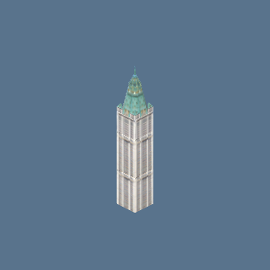 | ny_buildings.glb: woolworth | CIVIC:1 | 1 | 0.35
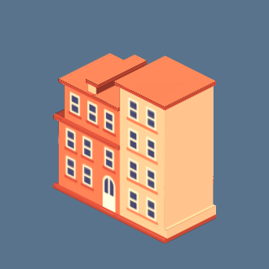 | carto.glb: town2 | QUARTER:1 | 1 | 0.35
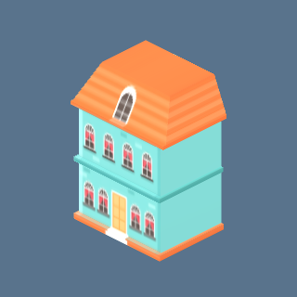 | carto.glb: house2 | APARTMENT:5, SUBURBAN:14 | 19 | 0.34
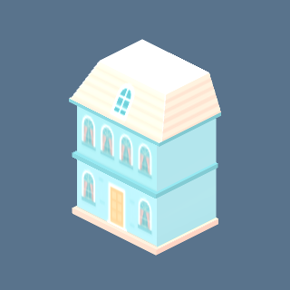 | carto.glb: town8 | QUARTER:2 | 2 | 0.34
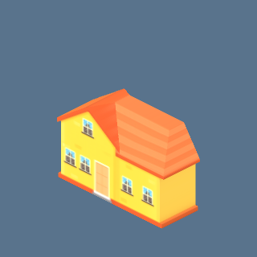 | carto.glb: house1 | APARTMENT:2, SUBURBAN:21 | 23 | 0.34
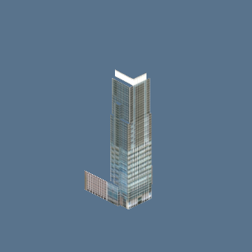 | towers_a.glb: towers_a_33_b | DOWNTOWN:1 | 1 | 0.34
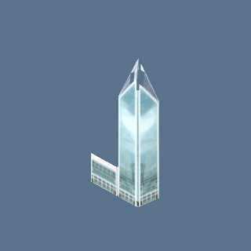 | towers_a.glb: towers_a_11_b | DOWNTOWN:2 | 2 | 0.34
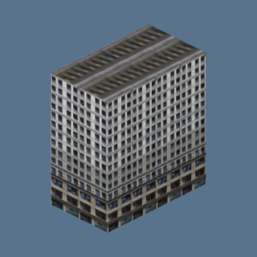 | ny_buildings.glb: ny_brick_2 | APARTMENT:6 | 6 | 0.34
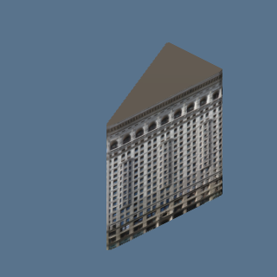 | ny_buildings.glb: flatiron | CIVIC:1 | 1 | 0.34
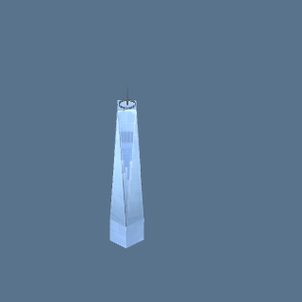 | ny_buildings.glb: one_wtc | CIVIC:1 | 1 | 0.34
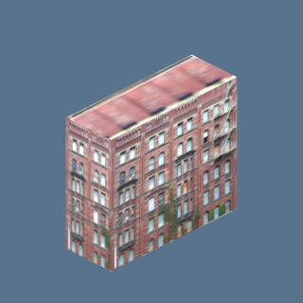 | ny_buildings.glb: ny_brick_5 | APARTMENT:1 | 1 | 0.33
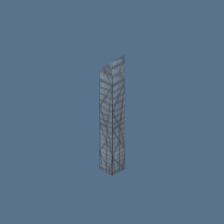 | ny_buildings.glb: ny_glass_2 | DOWNTOWN:1 | 1 | 0.33
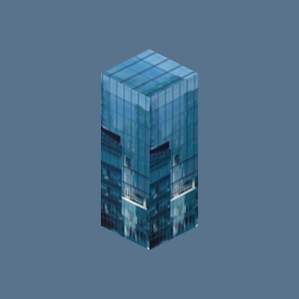 | ny_buildings.glb: ny_glass_4 | DOWNTOWN:2 | 2 | 0.33
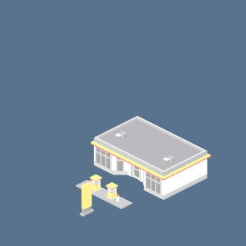 | free_mini.glb: m11 | CIVIC:1 | 1 | 0.30
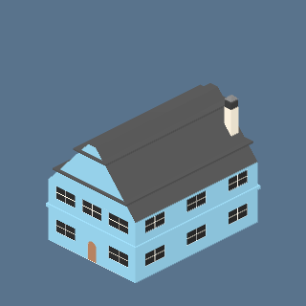 | euro.glb: blue_house | APARTMENT:2, SUBURBAN:10 | 12 | 0.30
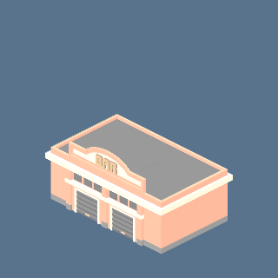 | free_mini.glb: m5 | COMMERCIAL:3 | 3 | 0.27
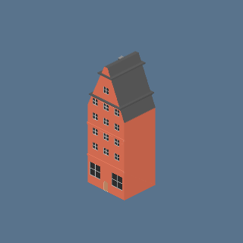 | euro.glb: townhouse_b | QUARTER:1 | 1 | 0.27
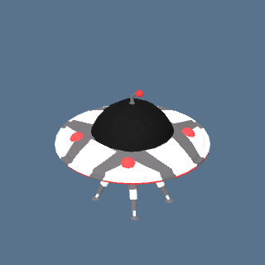 | ufo.glb: ufo | DESERT:1 | 1 | 0.27
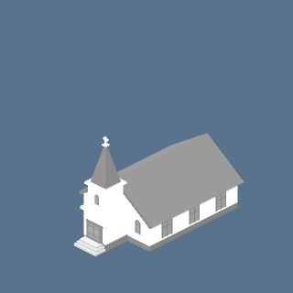 | free_mini.glb: m12 | CIVIC:1 | 1 | 0.26
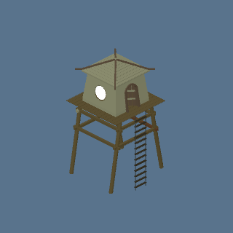 | watchtower.glb: watchtower | NATURE:2 | 2 | 0.24
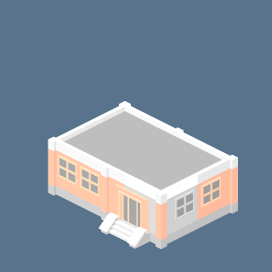 | free_mini.glb: m7 | COMMERCIAL:1, SUBURBAN:1 | 2 | 0.21
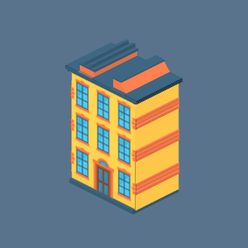 | carto.glb: town1 | QUARTER:1 | 1 | 0.21
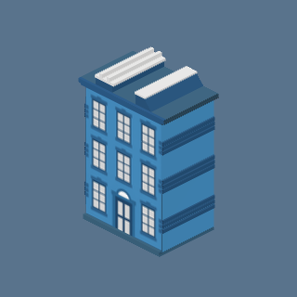 | carto.glb: town3 | APARTMENT:1 | 1 | 0.21
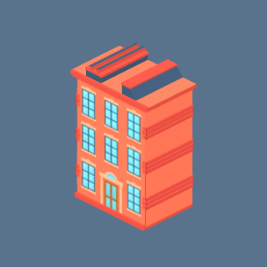 | carto.glb: town4 | APARTMENT:1 | 1 | 0.21
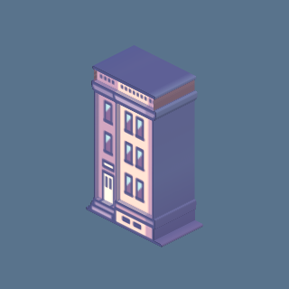 | carto.glb: town0 | APARTMENT:1 | 1 | 0.19
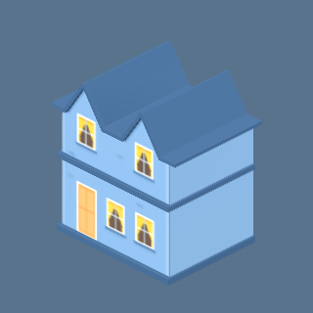 | carto.glb: house3 | APARTMENT:3, SUBURBAN:15 | 18 | 0.18
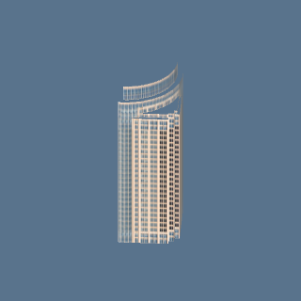 | towers_a.glb: towers_a_46_b | DOWNTOWN:1 | 1 | 0.18
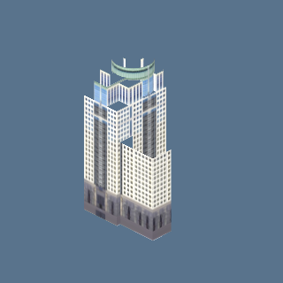 | towers_a.glb: towers_a_75_b | DOWNTOWN:1 | 1 | 0.18
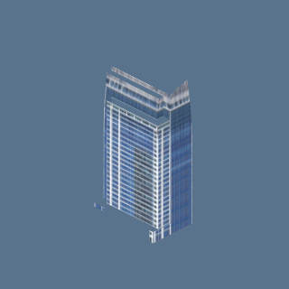 | towers_a.glb: towers_a_83_b | DOWNTOWN:1 | 1 | 0.17
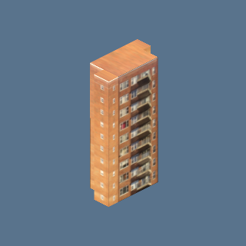 | ny_buildings.glb: ny_brick_4 | APARTMENT:8 | 8 | 0.17
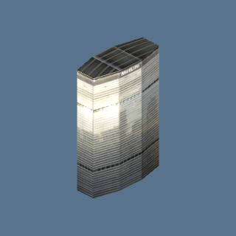 | ny_buildings.glb: metlife | CIVIC:1 | 1 | 0.17
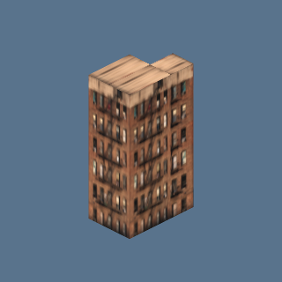 | ny_buildings.glb: ny_brick_3 | APARTMENT:4, COMMERCIAL:1 | 5 | 0.17
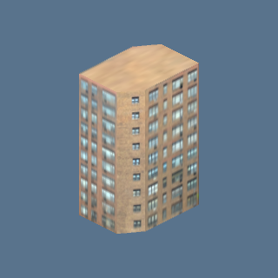 | ny_buildings.glb: ny_brick_6 | APARTMENT:1, COMMERCIAL:1 | 2 | 0.17
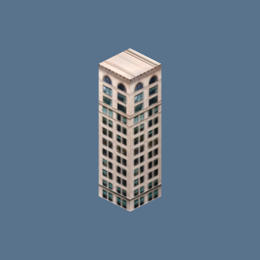 | ny_buildings.glb: ny_brick_1 | APARTMENT:2 | 2 | 0.17
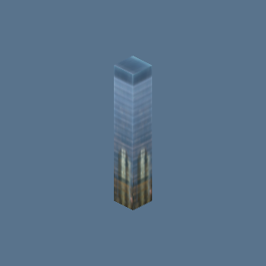 | ny_buildings.glb: ny_glass_1 | DOWNTOWN:1 | 1 | 0.17
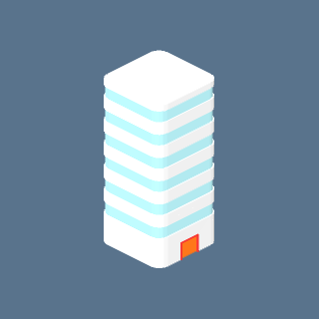 | quarter.glb: quarter_25_b | QUARTER:1 | 1 | 0.15
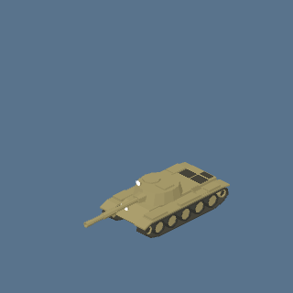 | Tank (roadblock): tank.glb: tank | NATURE (roadblock):5 | 5 | 0.14
 | tank.glb: tank | DESERT:1 | 1 | 0.14
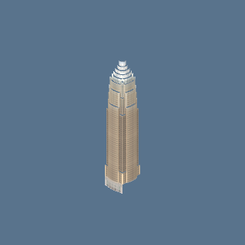 | towers_a.glb: towers_a_17_b | DOWNTOWN:2 | 2 | 0.13
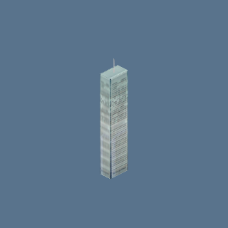 | ny_buildings.glb: ny_times | CIVIC:1 | 1 | 0.13
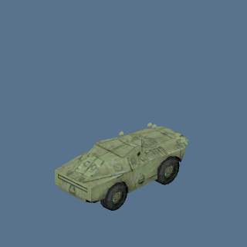 | army_apc.glb: apc_brdm | FOG: CHECKPOINT:2, FOG: NUCLEAR PLANT:2, FOG: VEHICLE PARK:4 | 8 | 0.13
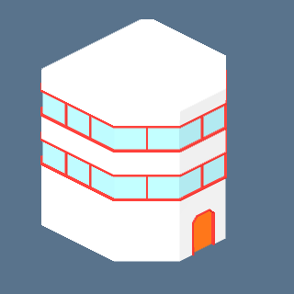 | quarter.glb: quarter_40_b | QUARTER:10 | 10 | 0.12
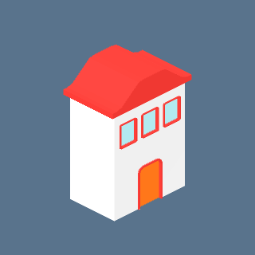 | quarter.glb: quarter_61_b | QUARTER:4 | 4 | 0.11
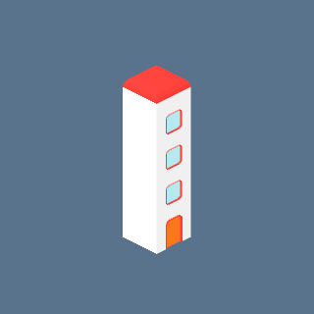 | quarter.glb: quarter_79_b | QUARTER:1 | 1 | 0.11
 | balloon.glb: balloon | CIVIC:1, DESERT:1, NATURE:4, POOR:1, QUARTER:1, SEA:6, SUBURBAN:1 | 15 | 0.10
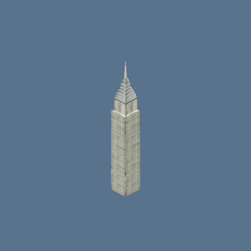 | ny_buildings.glb: chrysler | CIVIC:1 | 1 | 0.10
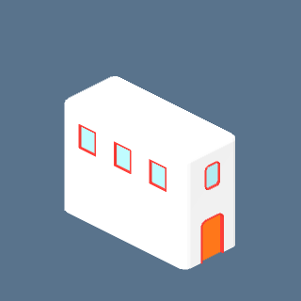 | quarter.glb: quarter_85_b | QUARTER:4 | 4 | 0.10
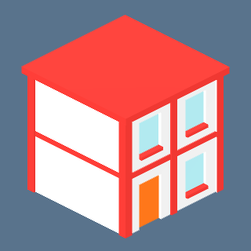 | quarter.glb: quarter_13_b | QUARTER:3 | 3 | 0.10
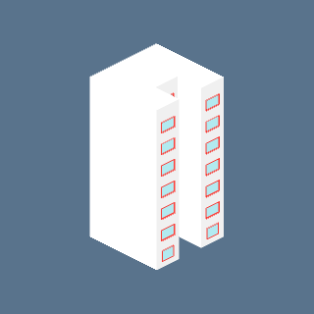 | quarter.glb: quarter_78_b | QUARTER:2 | 2 | 0.10
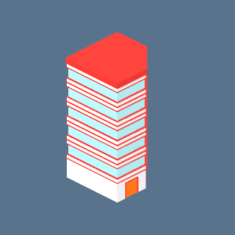 | quarter.glb: quarter_74_b | QUARTER:2 | 2 | 0.10
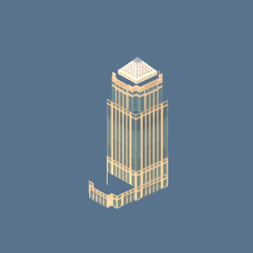 | towers_a.glb: towers_a_51_b | DOWNTOWN:1 | 1 | 0.09
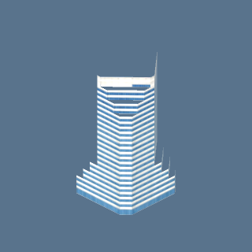 | towers_a.glb: towers_a_26_b | DOWNTOWN:4 | 4 | 0.09
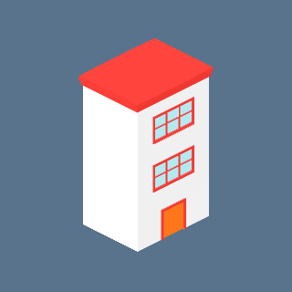 | quarter.glb: quarter_32_b | QUARTER:3 | 3 | 0.08
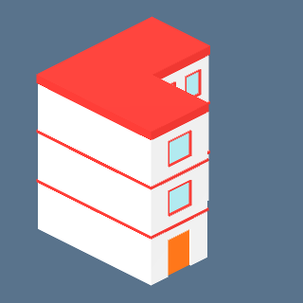 | quarter.glb: quarter_28_b | QUARTER:6 | 6 | 0.08
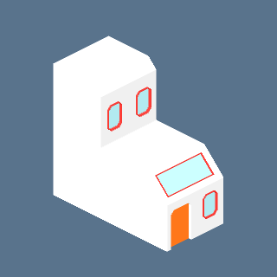 | quarter.glb: quarter_35_b | QUARTER:2 | 2 | 0.07
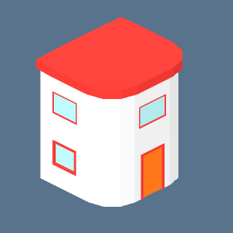 | quarter.glb: quarter_95_b | QUARTER:4 | 4 | 0.06
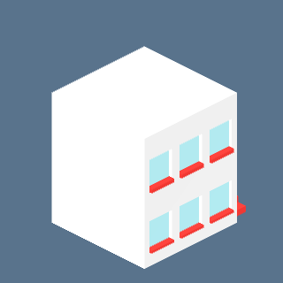 | quarter.glb: quarter_48_b | QUARTER:5 | 5 | 0.06
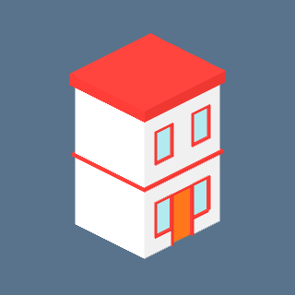 | quarter.glb: quarter_56_b | QUARTER:5 | 5 | 0.06
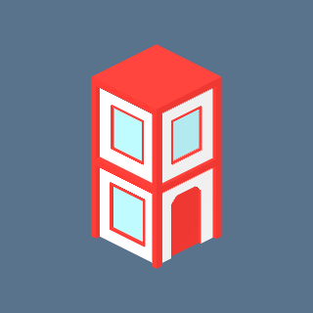 | quarter.glb: quarter_50_b | QUARTER:6 | 6 | 0.06
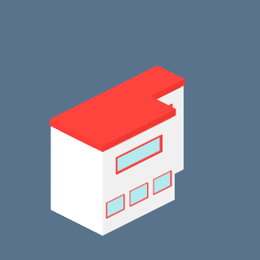 | quarter.glb: quarter_82_b | QUARTER:2 | 2 | 0.06
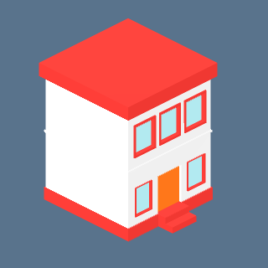 | quarter.glb: quarter_02_b | QUARTER:4 | 4 | 0.06
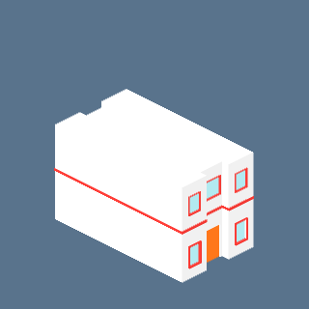 | quarter.glb: quarter_59_b | QUARTER:5 | 5 | 0.06
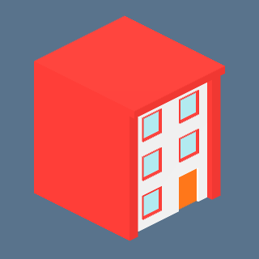 | quarter.glb: quarter_09_b | QUARTER:4 | 4 | 0.05
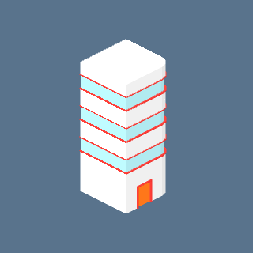 | quarter.glb: quarter_37_b | QUARTER:1 | 1 | 0.05
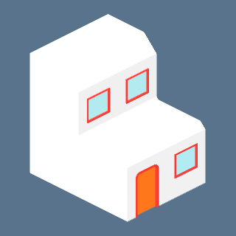 | quarter.glb: quarter_72_b | QUARTER:5 | 5 | 0.04
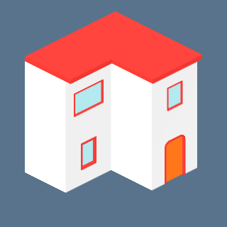 | quarter.glb: quarter_68_b | QUARTER:3 | 3 | 0.04
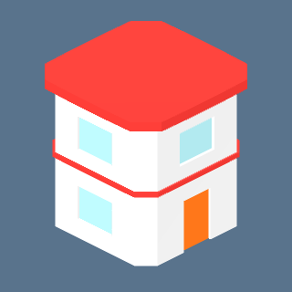 | quarter.glb: quarter_03_b | QUARTER:4 | 4 | 0.04
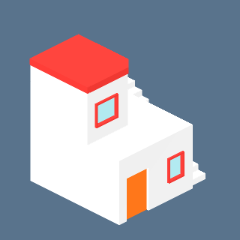 | quarter.glb: quarter_38_b | QUARTER:8 | 8 | 0.04
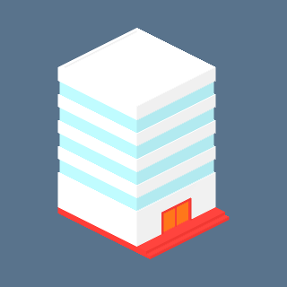 | quarter.glb: quarter_17_b | QUARTER:7 | 7 | 0.04
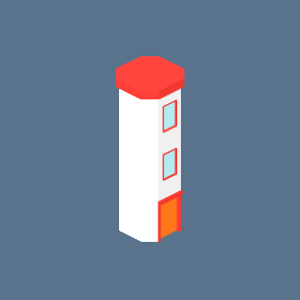 | quarter.glb: quarter_21_b | QUARTER:5 | 5 | 0.03
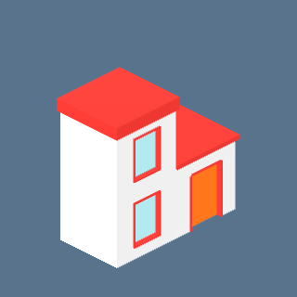 | quarter.glb: quarter_05_b | QUARTER:4 | 4 | 0.03
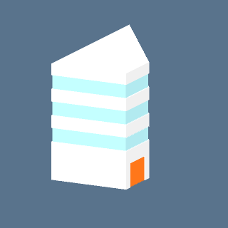 | quarter.glb: quarter_19_b | QUARTER:2 | 2 | 0.03
 | quarter.glb: quarter_46_b | QUARTER:8 | 8 | 0.03
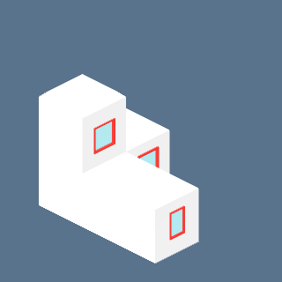 | quarter.glb: quarter_98_b | QUARTER:12 | 12 | 0.03
 | quarter.glb: quarter_14_b | QUARTER:2 | 2 | 0.02

